<Name> Project
Project Contacts:  Sponsor:  Project Manager:  Project Team:  Steering Committee: | Architecture  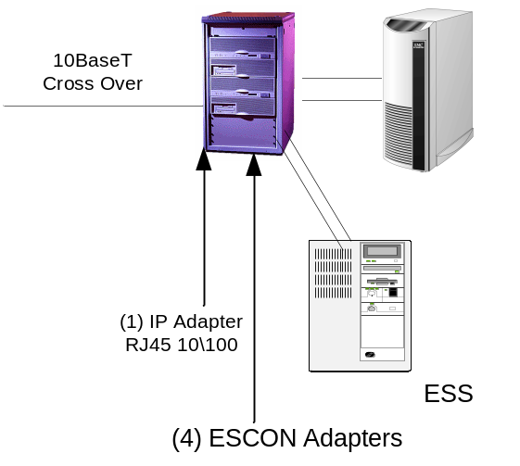
Scope
Brief scope statement

Assumptions  Constraints  Risks | Approach  - Steps or narrative explaining/showing project approach
Assumptions  Constraints  Risks | Updated: 11/11/2006
Project Timeline

2006
2007

2008

